**INTRODUCTION**

Computer-based methods are increasingly used to improve the quality of medical services. Artificial Intelligence (AI) is the area of computer science focusing on creating expert machines that can engage on behaviors that humans consider intelligent [1]. The proposed system DDTRS is for dealing with the problem of a disease diagnosis is an expert system. An expert system is a system that employs human knowledge captured in a computer to solve problems that ordinarily require human expertise. The expert system seeks and utilizes relevant information from their human users and from available knowledge bases to make recommendations. The main aim is to provide the expert-based health care to an under-served population of rural areas developing countries where the doctors are not easily available it is more likely to use by tech-friendly people who are very busy in their schedule [2]. Also, the other areas where there is a need for uniform health-care access include remote military bases security health-care facilities.

The idea of this project is to act as a facilitator by recording all the data entered by the patient i.e. symptoms entered by the user and case history given by the user’s and to diagnose the diseases of the patient to a greater extent if possible and help them cure their disease by consulting with experts. This project aims to change the structure of the current health-care system. Medical care will be delivered easily to the patient. This could reduce the cost of the patient for visiting doctors or to consult the doctor will also save the time of the patient [2]. Because of the massive volume, variety, and continuous updating of medical data, the efficient processing of medical data and the real-time response of the treatment recommendation has become an important issue. Fortunately, machine learning algorithms such as Support Vector Machine, Random Forest Classification Technique, Artificial Neural Network can be used to efficiently use the data.

**PROBLEM STATEMENT**

Due to the unavailability of specialized doctor and time, many patients suffer from severe diseases and not able to get proper medication in the early stages of the disease. Despite the generation and availability of abundant medical data related to patients, diseases, treatment plans, and their results, these data are not appropriately analyzed to extract useful knowledge and not efficiently shared among doctors and hospitals.

**LITERATURE REVIEW**

EXPERT systems (ES) are a branch of artificial intelligence (AI) and were developed by the AI community in the mid-1960s. An expert system can be defined as "an intelligent computer program that uses knowledge and inference procedures to solve problems that are difficult enough to require significant human expertise for their solutions [3]". We can infer from this definition that expertise can be transferred from a human to a computer and then stored in the computer in a suitable form that users can call upon the computer for specific advice as needed. Then the system can make inferences and arrive at a specific conclusion to give advice and explains, if necessary, the logic behind the advice.

[4] presented a disease diagnosis and treatment recommendation system based on the inspection report of a patient. Clustering technique has been used to cluster the inspection report to find the disease symptoms. Then association algorithms are used to find the link between the symptoms and the treatment.

[6] presents a comparative study of several classification methods for the task of recognizing traffic signs in urban areas. These classification methods are an artificial neural network (ANN), k-nearest neighbors (kNN), support vector machine (SVM), and random forest (RF). First, the HSI-based color segmentation process is applied to obtain candidate regions. Using the centroid-based feature, these regions will be classified into three shape classes, such as a circle, rectangle, and triangle. Hereafter, histograms of oriented gradient (HOG) features are extracted from each region that will be utilized in recognizing step. For comparison, well-known public databases will be used. The comparison based on the implementation result from those data with the different condition of intensity and angle of view. Comprehensive comparative results to illustrate the performance result of each classification method is presented. Performance of Random Forest For the training process of random forest, we used the library RFMS. We set the number of trees is equal to 100. Results present the performance matrix for three types of signs using RF. Surprisingly, RF gives the accuracy 100% for all types of sign.

**OBJECTIVE**

A recommendation system of disease diagnosis and treatment is to be developed to find a balance between the medical resources of developed and underdeveloped hospitals and to deliver health care, diagnose patients, provide therapy, suggest medicines and gives health tips related to users’ disease.

**METHODOLOGY**

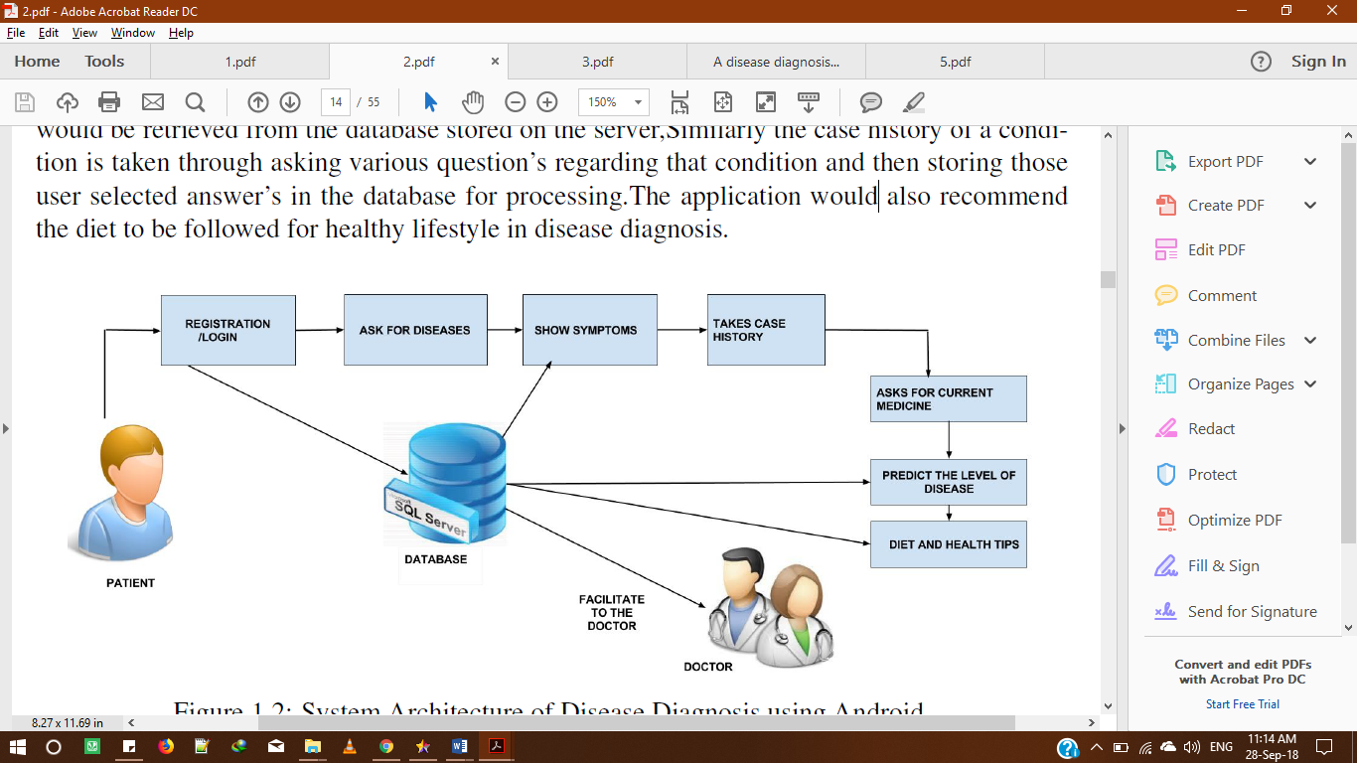

Fig. 1 System Architecture of Disease Diagnosis

Our project is designed for medical patients which are suffering from any kind of disease. Our project is a health care based system which is specially designed for medical patients. Our project will be acting as a facilitator and will forward the data to expert and case history of the patient. The application would start with basic registration formality Our project starts with a Registration form than taking certain user related detail’s such as gender, the weight of the user and then the user will be asked for the disease the user might be suffering from, then returning the symptoms. As our application works on client-server architecture the symptoms would be retrieved from the database stored on the server, Similarly, the case history of a condition is taken through asking various question’s regarding that condition and then storing those users selected answer’s in the database for processing. The application would also recommend the diet to be followed for a healthy lifestyle in disease diagnosis.

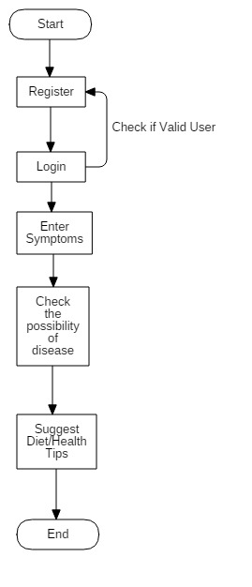

Fig. 2 Flow Chart

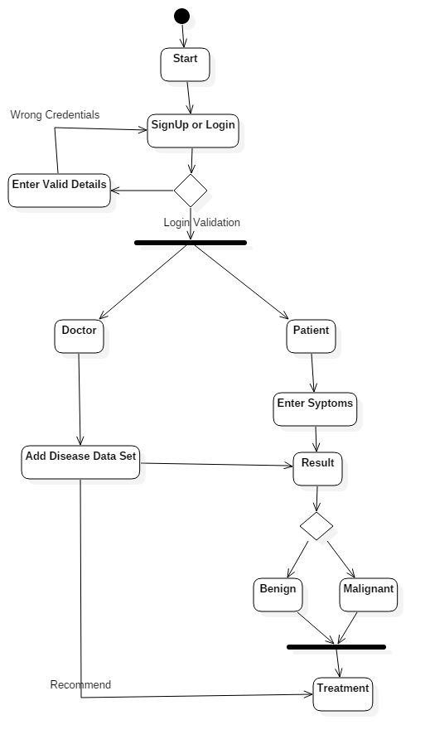

Fig. 3 Activity Diagram

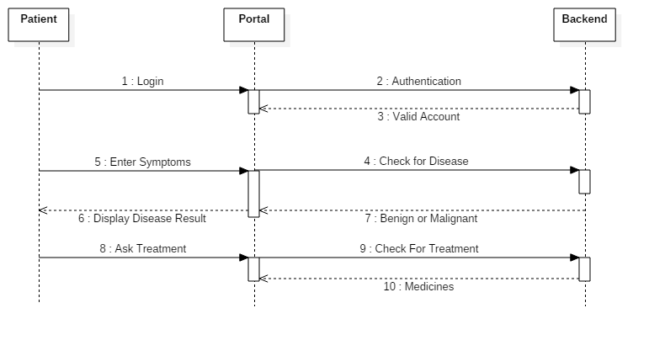

Fig. 4 Sequence Diagram

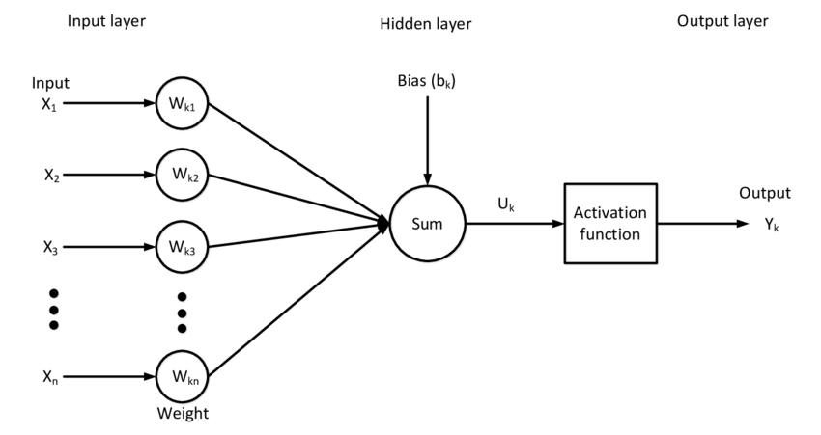

Fig. 5 Input layer, Hidden Layer & Output Layer

The input layers X1, X2, …..., Xm described above are the inputs which are independent variables each having applied a weight assigned to it. The weight W1, W2, …., Wm is adjusted so as to give appropriate results.

The following are the next steps when these inputs and weights are multiplied and sent to the neuron:

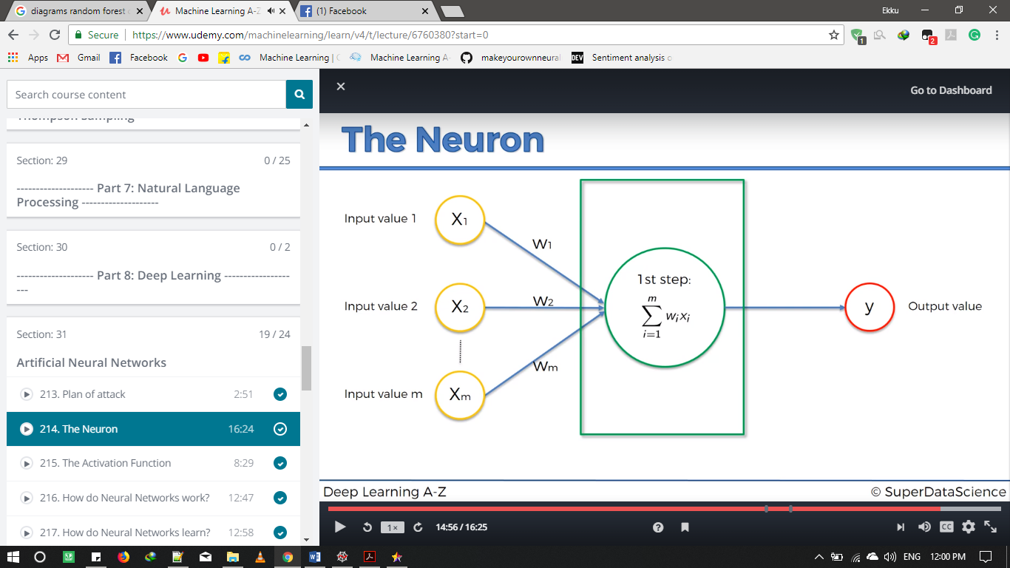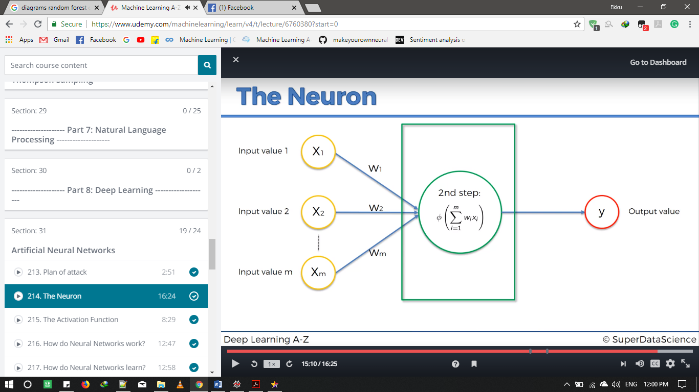

Fig. 6 Inside Neuron

***Activation****functions* are really important for an Artificial Neural Network to learn and make sense of something really complicated and Non-linear complex functional mappings between the inputs and response variable. *They introduce non-linear properties to our Network*. ***Their main purpose is to convert an input signal of a node in an A-NN to an output signal.*** That output signal now is used as an input in the next layer in the stack.

Specifically, in A-NN we do the sum of products of inputs(**X**) and their corresponding Weights(**W**) and apply an Activation function **f(x)** to it to get the output of that layer and feed it as an input to the next layer.

**SYSTEM REQUIREMENTS**

* Processor: Intel core i5
* RAM: 8 GB
* Graphic Card: Nvidia M920
* Software Requirements: Anaconda – Spyder.
* Python 2.7/3.6

**OUTPUTS**

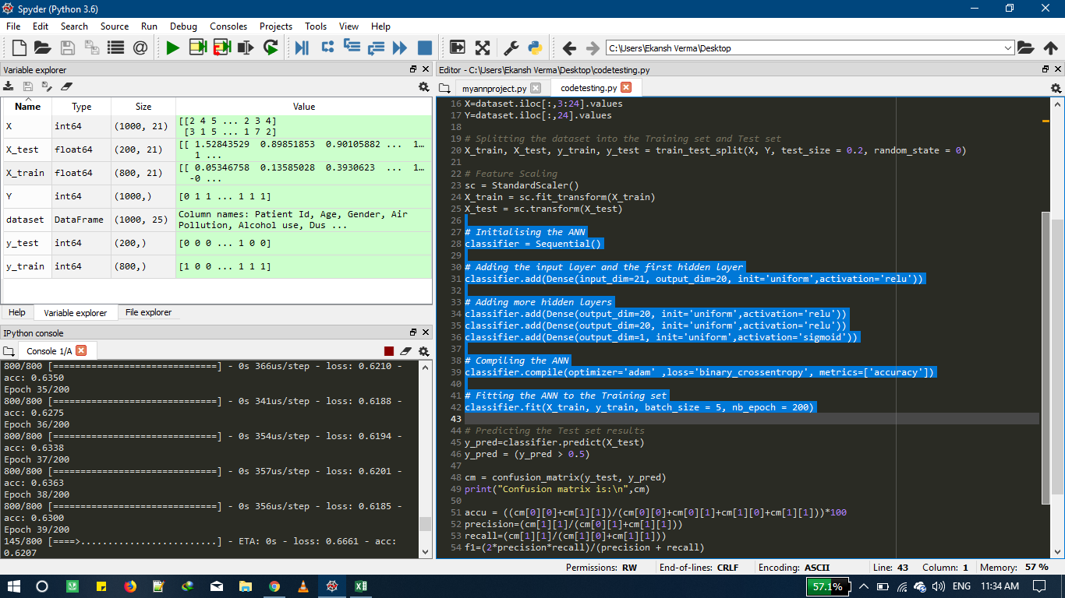

Fig. 7 Screenshot-1

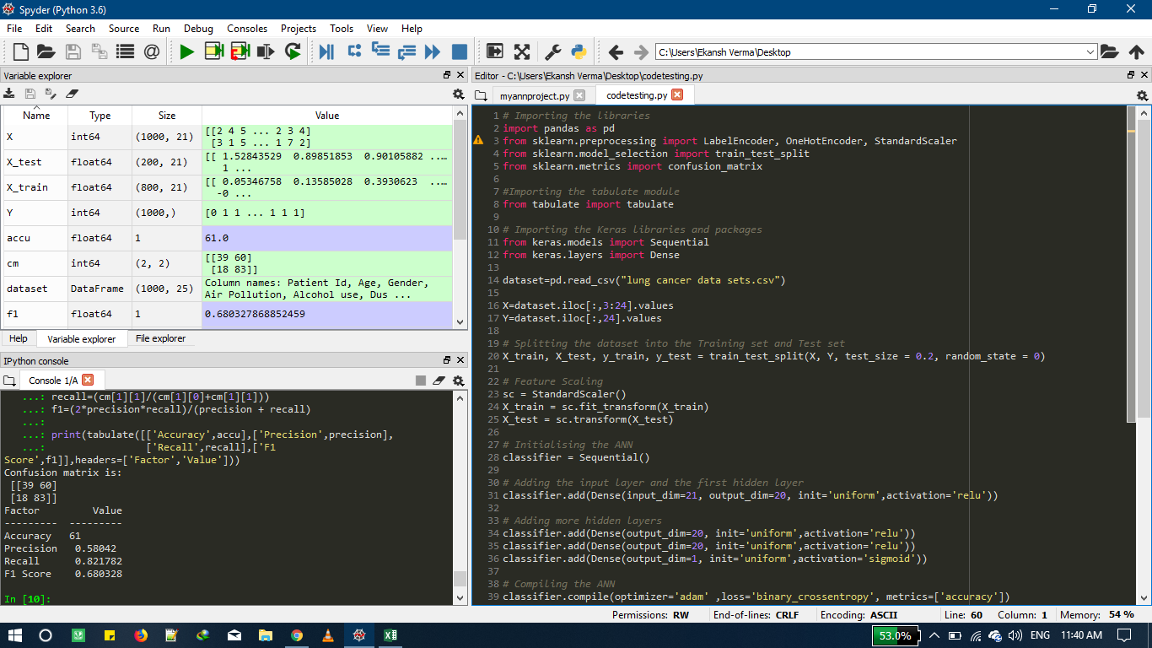

Fig. 8 Screenshot-2

**PERT CHART**

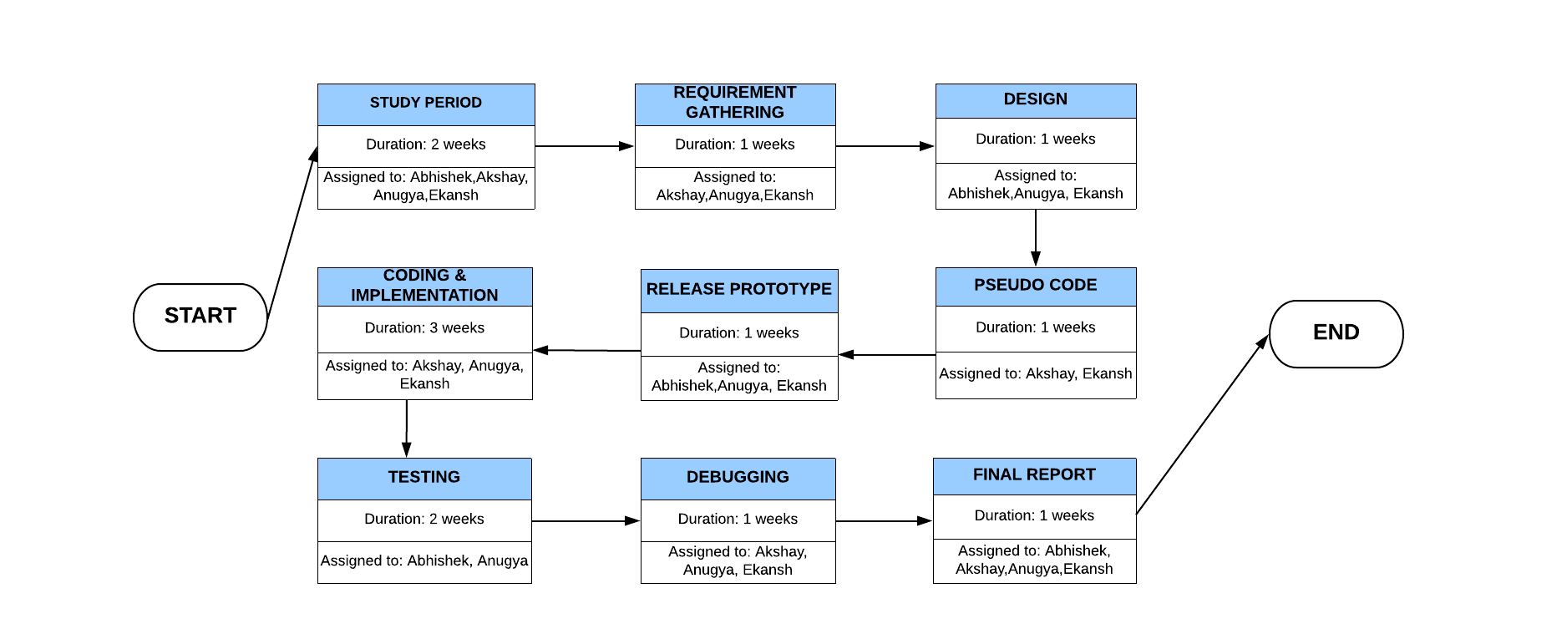

Fig. 9 PERT Chart

**REFERENCES**

1. P.Santosh Kumar Patra, Dipti Prava Sahu, Indrajit Mandal, “An Expert System for Diagnosis of Human Diseases”, 2010 International Journal of Computer Applications (0975 – 8887) Volume 1 – No. 13.
2. Syed Mohd Atif Hanif Hazara, Deshmukh Mohsin Mahmood Goher, Shaikh Saman Mohammad Umar Asma, Rizvi Irfan Shabihul Hasan Nasrin Fatima, “Disease Diagnosis Using Android”, 2015, DOI: 10.15680/IJIRCCE.2015. 0310180.
3. Dipanwita Biswas, Sagar Bairagi , Neelam Panse & Nirmala Shinde, “Disease Diagnosis System”, International Journal of Computer Science & Informatics, Volume-I, Issue-II, 2011.
4. Jianguo Chen, Kenli Li, Huigui Rong, Kashif Bilal, Nan Yang, Keqin Li, “A disease diagnosis and treatment recommendation system based on big data mining and cloud computing”, Chen et al. / Information Sciences 435 (2018) 124–149.
5. HCLOUD – A Cloud Architecture for Healthcare.
6. Wahyono, Kang-Hyun Jo, “A Comparative Study of Classification Methods for Traffic Signs Recognition”, 2014 IEEE International Conference on Industrial Technology (ICIT), Feb. 26 - Mar. 1, 2014, Busan, Korea.